

Safety Plan Lane Assistance

**Document Version: 1.0**

**Released on 2018-06-22**



# Document history

|  |  |  |  |
| --- | --- | --- | --- |
| Date | Version | Editor | Description |
| 2018-06-22 | 1.0 | Deepak Kumar Singh | Safety Plan |
|  |  |  |  |
|  |  |  |  |
|  |  |  |  |
|  |  |  |  |

# 

# Table of Contents

Introduction 4

Purpose of the Safety Plan 4

Scope of the Project 4

Deliverables of the Project 4

Item Definition 5

Goals and Measures 6

Goals 6

Measures 6

Safety Culture 7

Safety Lifecycle Tailoring 7

Roles 8

Development Interface Agreement 8

Confirmation Measures 8

# Introduction

## Purpose of the Safety Plan

The purpose of this document is to define a framework for safety plan for lane assistance system. The document includes details about roles and responsibility for the lane assistance’s functional safety.

## Scope of the Project

For the lane assistance project, the following safety lifecycle phases are in scope:

Concept phase

Product Development at the System Level

Product Development at the Software Level

The following phases are out of scope:

Product Development at the Hardware Level

Production and Operation

## Deliverables of the Project

The deliverables of the project are:

Safety Plan

Hazard Analysis and Risk Assessment

Functional Safety Concept

Technical Safety Concept

Software Safety Requirements and Architecture

# Item Definition

The main functions of Lane Assistance system are as below:

1. Lane keeping assistance function: When car moves off the lane, this system turns steering wheel towards the center of lane to keep car in lane.
2. Lane departure warning function: When car drifts off the lane, steering wheel vibrates to warn/inform the driver.

Subsystems used to implement lane assistance are as below:

1. Camera subsystem:
   1. Camera Sensor
   2. Camera Sensor ECU
2. Power Steering subsystem:
   1. Electronic Power steering ECU
   2. Driver steering torque sensor
   3. Motor providing torque to steering wheel.
3. Display subsystem:
   1. Car display
   2. Car display ECU

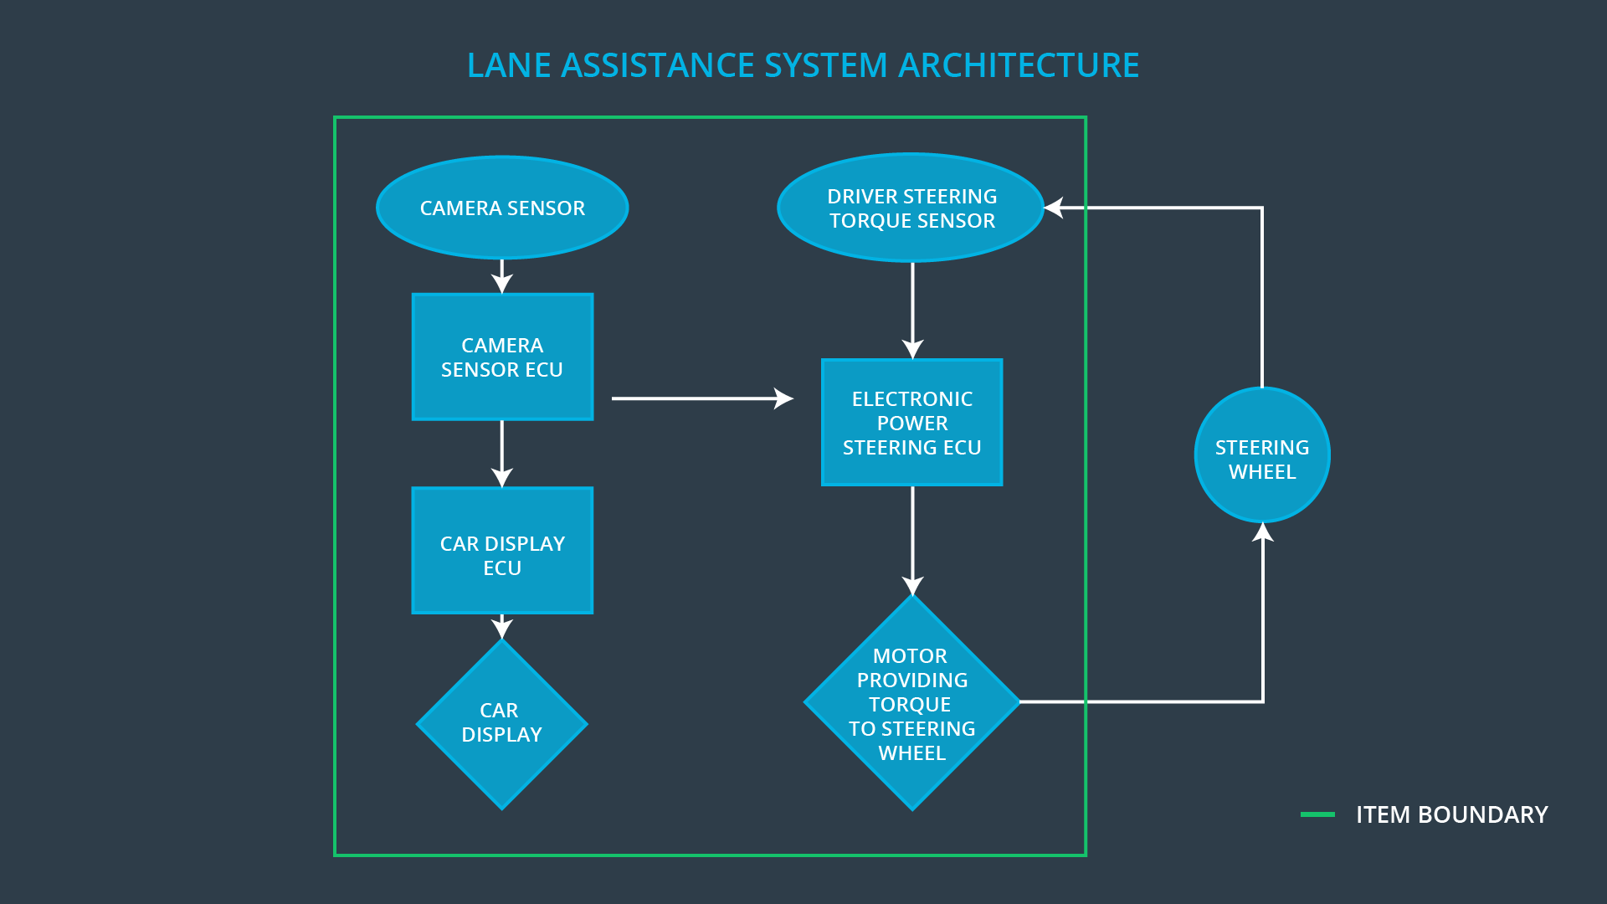

When car starts drifting towards side of lane, camera sensor senses the lane and sends a signal to car display system and steering wheel torque system. Car display system will display warning on car dashboard and steering wheel torque provider system will send signal to vibrate steering wheel and will turn steering wheel towards the center of the lane. When driver turns on the lane change indicator or switches off the lane assistance system, the system will stop applying torque on steering wheel and displaying warning on car dashboard.

The Lane Assistance system does not support functionalities listed below:

1. Collision detection and collision avoidance
2. Pedestrian detection

# Goals and Measures

## Goals

1. Identify potential risks associated with malfunctioning of lane assistance system.
2. Measure severity of risk.
3. Lower the risk up to the current Standard of society.

## Measures

|  |  |  |
| --- | --- | --- |
| Measures and Activities | Responsibility | Timeline |
| Follow safety processes | All Team Members | Constantly |
| Create and sustain a safety culture | Safety Manager | Constantly |
| Coordinate and document the planned safety activities | Safety Manager | Constantly |
| Allocate resources with adequate functional safety competency | Project Manager | Within 2 weeks of start of project |
| Tailor the safety lifecycle | Safety Manager | Within 4 weeks of start of project |
| Plan the safety activities of the safety lifecycle | Safety Manager | Within 4 weeks of start of project |
| Perform regular functional safety audits | Safety Auditor | Once every 2 months |
| Perform functional safety pre-assessment prior to audit by external functional safety assessor | Safety Manager | 3 months prior to main assessment |
| Perform functional safety assessment | Safety Assessor | Conclusion of functional safety activities |

# Safety Culture

Below are the characteristics of our safety culture:

1) **High priority**: safety has been given the highest priority among competing constraints like cost and productivity

2) **Accountability**: processes which we follow ensure accountability such that design decisions are traceable back to the people and teams who made the decisions

3) **Rewards**: we motivates and supports the achievement of functional safety

4) **Penalties**: we penalizes shortcuts that jeopardize safety or quality

5) **Independence**: teams who design and develop a product are independent from the teams who audit the work

6) **Well defined processes**: our design and management processes are clearly defined

7) **Resources**: here we have projects which have necessary resources including people with appropriate skills

8) **Diversity**: intellectual diversity is sought after, valued and integrated into processes

9) **Communication**: we have various communication channels to encourage disclosure of problems

# Safety Lifecycle Tailoring

Safety lifecycle phases are as below:

1. Concept phase
2. Product Development at the System Level
3. Product Development at the Software Level

# Roles

|  |  |
| --- | --- |
| Role | Org |
| Functional Safety Manager- Item Level | OEM |
| Functional Safety Engineer- Item Level | OEM |
| Project Manager - Item Level | OEM |
| Functional Safety Manager- Component Level | Tier-1 |
| Functional Safety Engineer- Component Level | Tier-1 |
| Functional Safety Auditor | OEM or external |
| Functional Safety Assessor | OEM or external |

# Development Interface Agreement

**Purpose**:  To define the roles and responsibilities between OEM involved in developing the system and to ensure that all parties are developing safe vehicles in compliance with ISO 26262

In this project, the OEM is supplying a functioning lane assistance system. We as functional safety engineer sharing social responsibility need to analyze and modify the various sub-systems from a functional safety viewpoint.

**Responsibilities of OEM:** To provide functioning Lane Assistance system.

**Responsibilities of Tier 1:** To verify lane assistance system as well as various subsystems adhere to ISO 26262 standards.

# Confirmation Measures

Confirmation measures serve two purposes:

1. Functional safety project conforms to ISO 26262, and
2. The project really does make the vehicle safer.

The people who carry out confirmation measures need to be independent from the people who actually developed the project.

There are various different ways to carry out confirmation measures listed below:

##### **Confirmation review**: Ensures that the project complies with ISO 26262. As the product is designed and developed, an independent person would review the work to make sure ISO 26262 is being followed.

##### **Functional safety audit***:* Checking to make sure that the actual implementation of the project conforms to the safety plan is called a functional safety audit.

##### **Functional safety assessment***:* Confirming that plans, designs and developed products actually achieve functional safety is called a functional safety assessment.

A safety plan could have other sections that we are not including here. For example, a safety plan would probably contain a complete project schedule.

There might also be a "Supporting Process Management" section that would cover "Part 8: Supporting Processes" of the ISO 26262 functional safety standard. This would include descriptions of how the company handles requirements management, change management, configuration management, documentation management, and software tool usage and confidence.

Similarly, a confirmation measures section would go into more detail about how each confirmation will be carried out.